BioMat HEAT SETTINGS

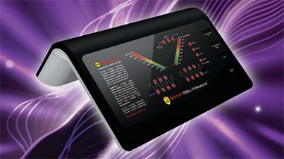

Your BioMat 7000 MX control box features several different temperature settings. Select for your comfort, the benefit you are wishing to achieve, and/or your personal health issue(s).

No Temperature
Negative Ions Only – lights on control panel bottom light up and “dance.” This means you have engaged the negative ions (and there’s no heat turned on)

Cool Vitality: 95° - 104°
Safest for Sensitive and Extended Use

Subtle Warmth: 113° - 122°
One Hour or More

Deeply Penetrating Warmth: 131° - 140°
9 to 90 Minute Sessions

Deep Heat and Maximum Therapeutics: 149° - 158°
Power Sessions of ½ to 1 Hour

